Name : Armaan Tatle | Student ID :N01617608
Name : | Student ID :
Date:April 19 2026 | Professor Signature:

Lab 9– MIPS Architecture Design – CPU Code Execution

The purpose of this lab is to finish the CPU instruction functions required by the MIPS simulator we build in the last lab.
Procedures
- Hint: Starting from lab 7, the code will be more and more complicated. As a result, you should consider having a consistent development environment and backup your code more frequently.
- Study the MIPS instruction set definition based on the course materials and lecture notes. Follow the examples your professor gives you during the class time, make sure you understand the 32-bit instruction set structure and how to translate the assembly code into its 32-bit machine code.
- Now try to understand the code, and finish the following functions in lab8_9.c:
CPU_Execution(unsigned char opcode, unsigned int machineCode, char *mem)
- Uncomment the following statement in lab8_9.c, so that function CPU_Execution will be included into the project.
// CPU_Execution(opcode, machineCode, mem);

Please follow the following submission requirements for this lab:
- Must demo your code to the professor to get the signature from the professor. (50%)
- Submit the screenshots of the running results and the final memory dump of Data section, and all the register contents. Screenshots must have time/date of the local computer. (30%)
- The lab report is due on the blackboard.
- Answer this question in the text with your submission: (20%)
  - Please briefly describe the function of the code MIPS.asm
Explantion in case it does not appear on BB:
The MIPS.asm program is designed to swap the values stored in two arrays, testdata1 and testdata2. It starts by loading the memory addresses of both arrays and a counter into registers. The counter holds the value 32, which represents the total number of bytes that need to be processed.
The program then enters a loop where it compares the current position with the counter to decide when to stop. Inside the loop, it loads one word from each array, swaps them by storing each value into the other array’s location, and then moves both pointers forward by 4 bytes to access the next word. It also updates a loop counter to keep track of progress.
This process repeats until all the values have been swapped. In the output, this can be seen through the changes in register values and the data memory dump, which shows that the contents of the two arrays have been exchanged.

Screenshots:
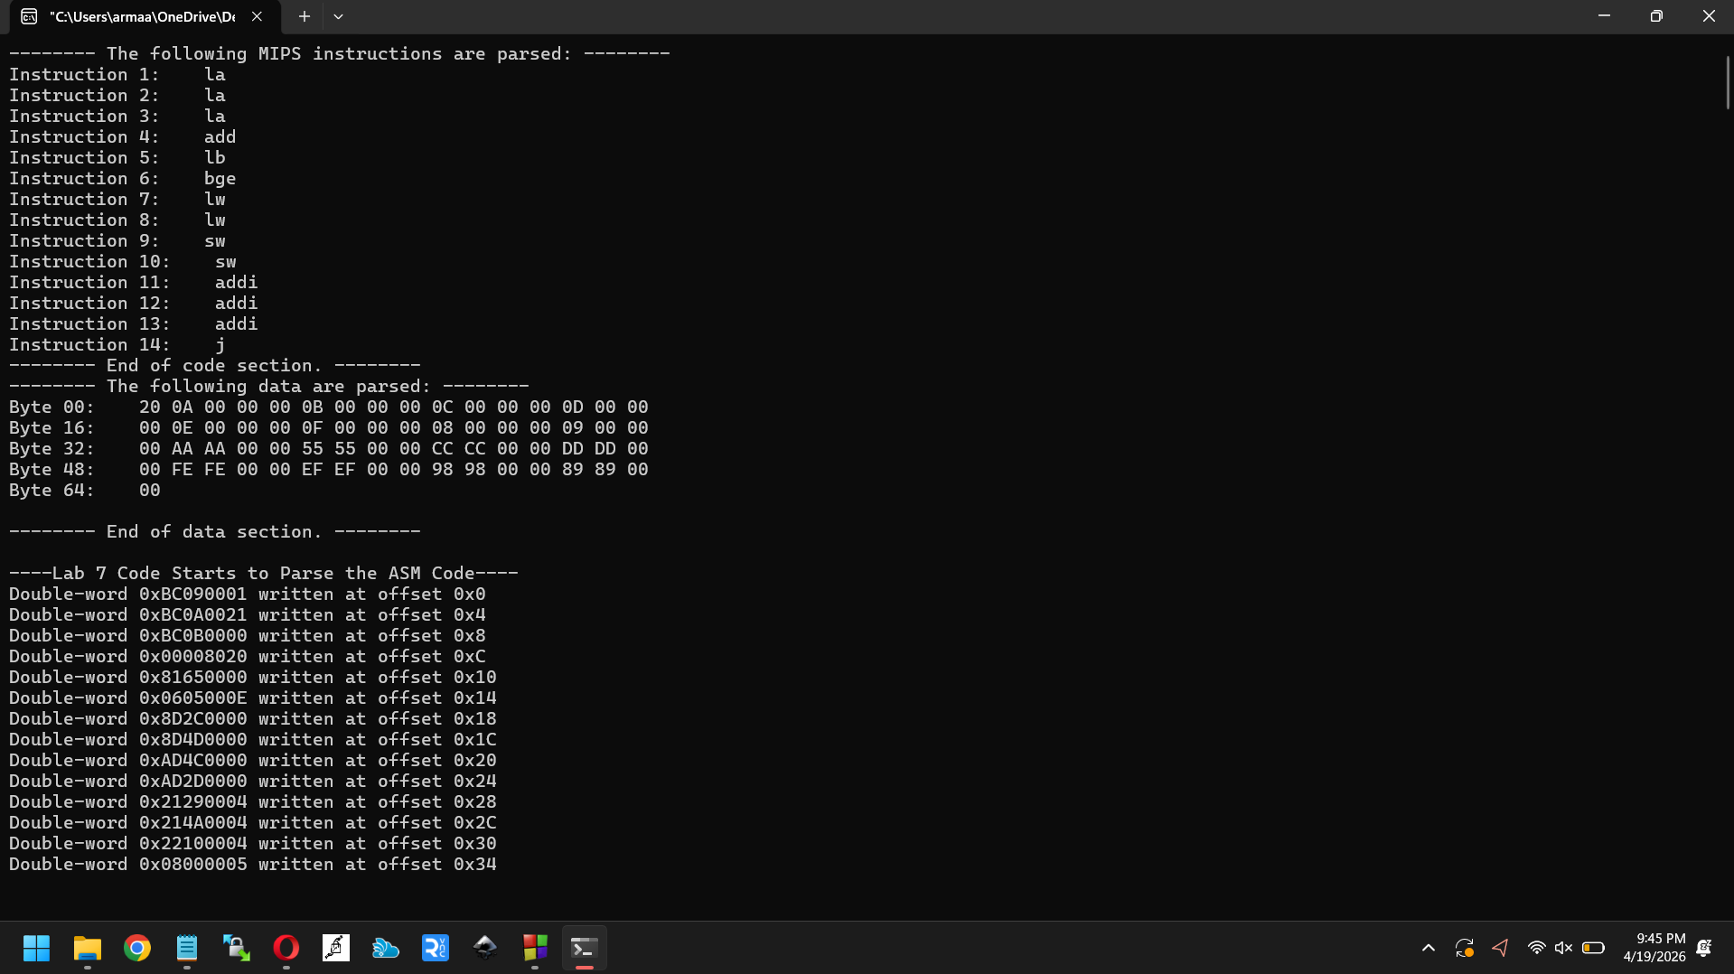
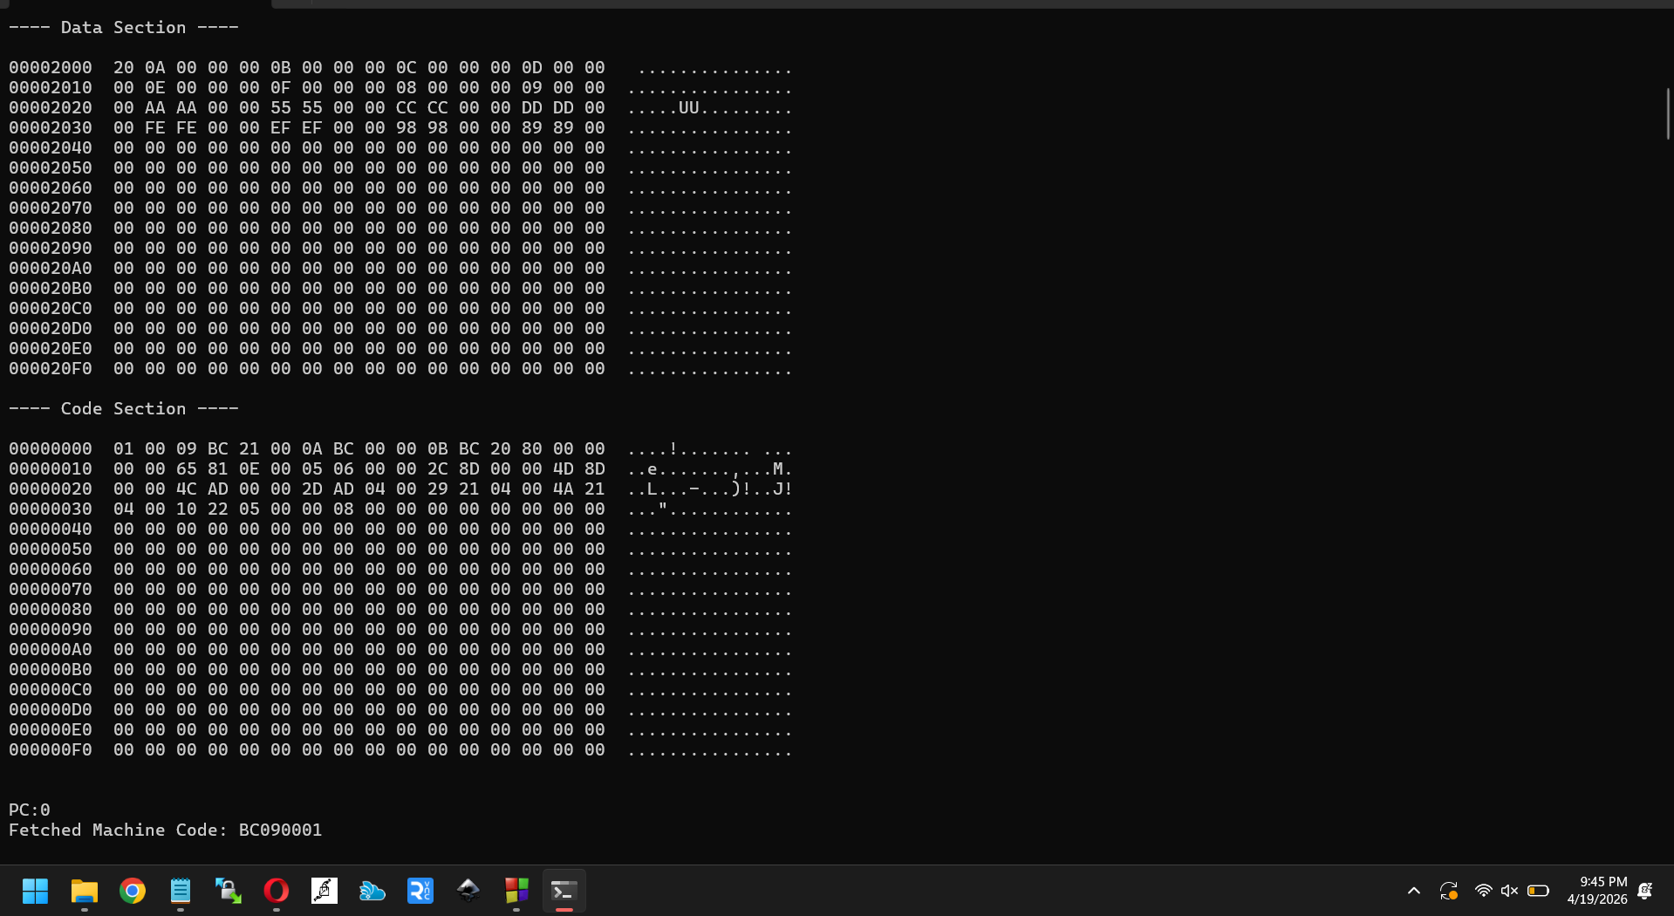

Lab 9:
